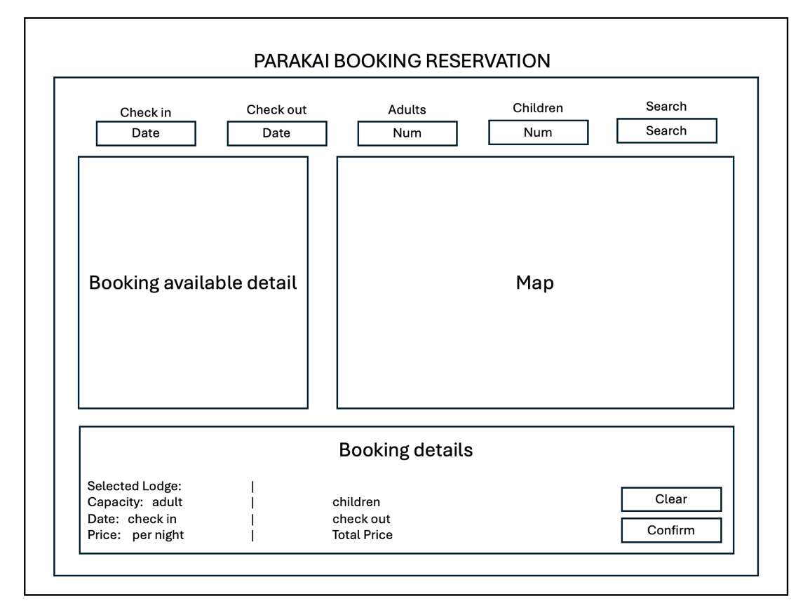

1. Search Bar:

* The search bar located at the top of the booking system is used to search for available rooms. For example, you can search for a room suitable for 2 people.

1. Layout:

* On the left, it displays the booking details that the user needs to fill in.
* On the right, it shows the room numbers that the user can select.
* The larger the square, the higher the price and greater the capacity of the room. This visually indicates the characteristics of the room based on the square's size.

1. Room Selection and Booking Process:

* The user enters their booking details, views the available rooms, and presses the "Select" button.
* Once selected, all user details are displayed, and the total price and price per night are calculated.
* When the user presses the "Confirm" button, a message will be displayed indicating that the booking has been confirmed.

1. Room Information Display:

* Hovering over the room location will display a popup with information about the room, including the price, image, and capacity.

1. Booking System Validation:

* The system follows the assignment requirements, ensuring that users cannot book a room using past dates and that only current or future dates are allowed.
* It also includes features to check if the booking is available.